Step-by-Step: Installing

PDF Camp Printer

| August-20 |

**Document Overview**

**Documentation Goals**

This documentation is intended to provide step by step instructions for ***installing the PDF Camp Printer****.*

**Table of Contents**

**Installation Steps** 2

Install Software 2

Change Printer Setting for Advantzware 2

Step One: Open Devices & Printers 2

Step Two: Open PDFCamp Printer Properties 3

Step Three: Register Product 5

# **Installation Steps**

## Install Software

* Under pdfcamp directory find pdfcamp_enterprise.exe
* ***“Double-click”*** to run the program.
* Proceed with the default installation steps.

## Change Printer Setting for Advantzware

### Step One: Open Devices & Printers

#### Start Menu

Within the destination workstation, the user may click on either the ***“Start Menu”*** or ***“Windows Icon”*** in the bottom corner of the desktop. This will open the *User Start Menu*.

Once this window is open, select the ***“Devices and Printers”*** button in order to open the “*Devices and Printers*” folder in Windows Explorer.

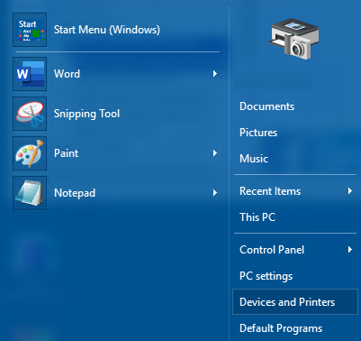

#### Devices & Printers

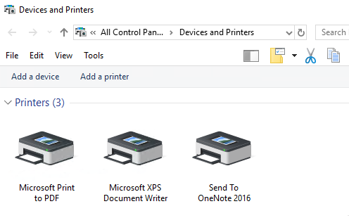

### Step Two: Open PDFCamp Printer Properties

The user should ***“Right-click”*** on the *PDFCamp Printer*, and choose *Properties*.

#### General Properties

Select the ***“Printing Preferences”*** button.

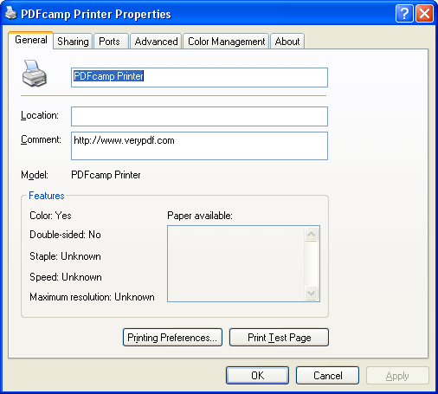

#### Page Size

The user must choose the *Paper Size* from the drop-down menu in the *Page Size* section of the screen. Please choose the *Letter (8.5 x 11 in)* option. Then, the user should press the ***“Apply”*** button at the bottom of the screen in order to apply the changes.

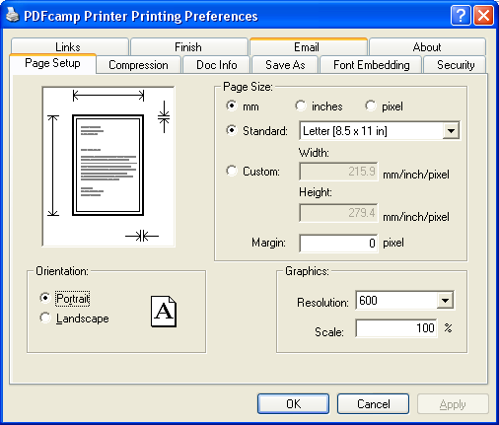

#### Compression Tab

Select the ***“Compression”*** tab at the top of the screen. Then, make sure that the settings are as follows:

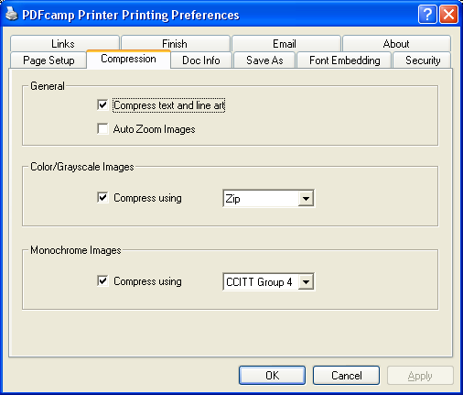

Then, the user should press the ***“Apply”*** button at the bottom of the screen in order to apply the changes.

#### Save As Tab

Select the ***“Save As”*** tab at the top of the screen. Then, make sure that the settings are as follows:

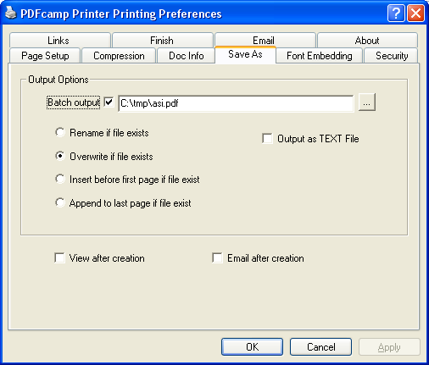

* Batch Output checked and in the box type – c:\tmp\asi.pdf
* Make sure Overwrite if file exist is selected.
* Make sure View after Creation and Email after creation is turned off.

Then, the user should press the ***“Apply”*** button at the bottom of the screen in order to apply the changes.

### Step Three: Register Product

#### About Tab

Select the ***“About”*** tab at the top of the screen. Then, make sure that the settings are as follows:

* Enter Registration Code : 35V2X1B3U389PJ78
* Click ***“Register”***. If any error occurs, contact Advantzware.